Amazon E-Commerce Database Management System

DBMS-SELLER AND INVENTORY MANAGEMENT

1.DATABASE DESIGN
1.1 Seller Table
Seller_ID | Seller_Name | Email | Phone | Address
1 | ABC Electronics | abc@gmail.com | 9876543210 | Chennai
2 | Tech World | tech@gmail.com | 9876543211 | Coimbatore
3 | Fashion Hub | fashion@gmail.com | 9876543212 | Madurai
4 | Home Needs | home@gmail.com | 9876543213 | Chennai
5 | Book Point | book@gmail.com | 9876543214 | Trichy

1.2 INVENTORY TABLE:
Inventory_ID | Seller_ID | Product_ID | Stock_Quantity | Reorder_Level
1 | 1 | 101 | 50 | 10
2 | 1 | 102 | 35 | 10
3 | 2 | 103 | 60 | 15
4 | 3 | 104 | 3 | 5
5 | 4 | 105 | 40 | 10

2.TABLE RELATIONSHIPS:

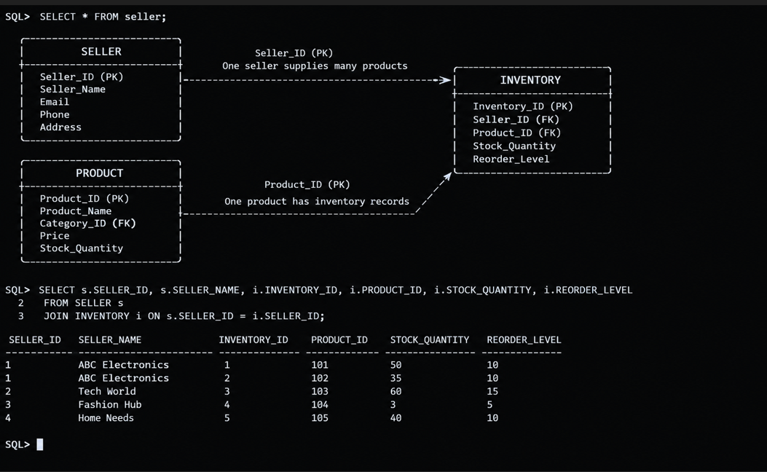

3.TABLE CREATION:
3.1 CREATE SELLER TABLE:
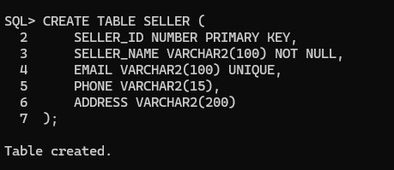

3.2 CREATE INVENTORY TABLE:
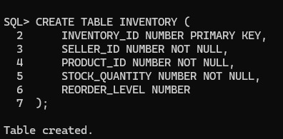

4.SELLER DATA INSERTION:
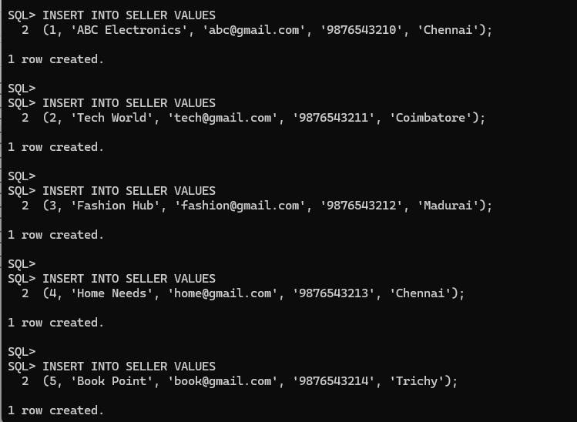

5.INVENTORY DATA INSERTION:
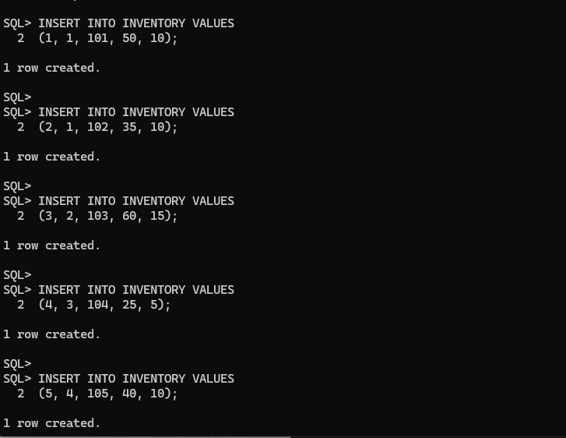

6.SELLER PRODUCT INFORMATION:
6.1 DISPLAY SELLER ANDD PRODUCT DETAILS:
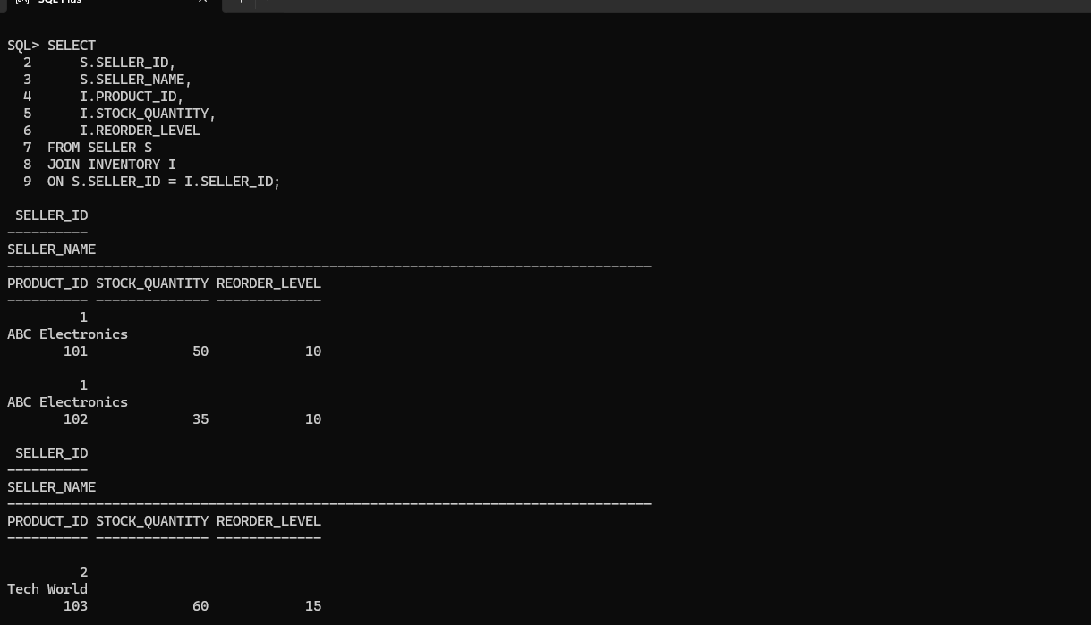

7.INVENTORY STATUS:
7.1 DISPLAY AVAILABLE PRODUCTS:
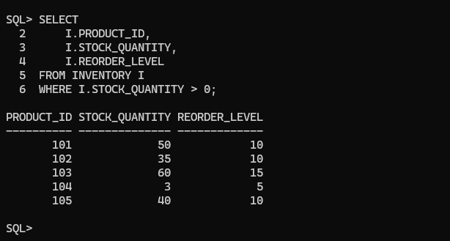

7.2 DISPLAY UNAVAILABLE PRODUCTS:
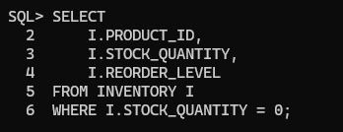

8.INVENTORY UPDATE:
Demonstrate update stock information
